Set up the firmware upload and development environment:
Step 1. After correctly following the hardware assembly guide. Download and install the flash download tool to upload the given binary files to the Board
By clicking on this Link: Flash Download Tool User Guide
After downloading the Flash download tool extract the files
Next open the .EXE files make sure the following selections are done for Chiptype and WorkMode
as shown below in image and click OK
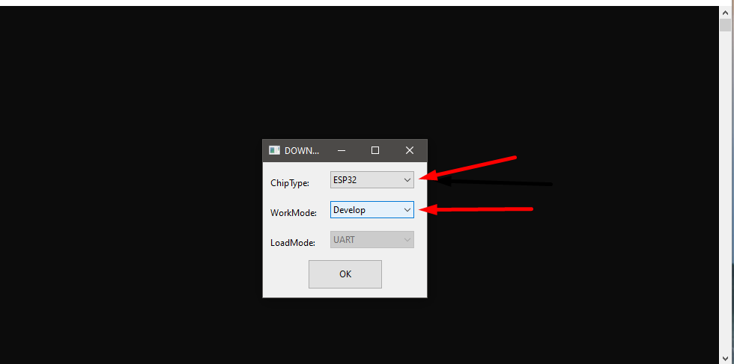
After clicking OK a pop up window will appear as shown in image below and some selections need to be made on this window as illustrated.
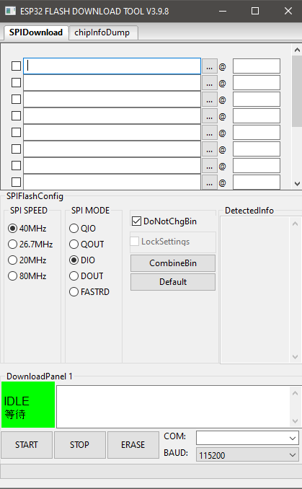
Guide for uploading Merged Binary files
As shown on the image below Click on the (…)(three Dots) to locate the provided Merged binary files Next make sure that there correct address are selected as shown in image below. Now upload the merged binary files by selecting the correct COM port on which the Voltlink programmer is attached and setting the Baud rate to 115200 as shown in image below and click start
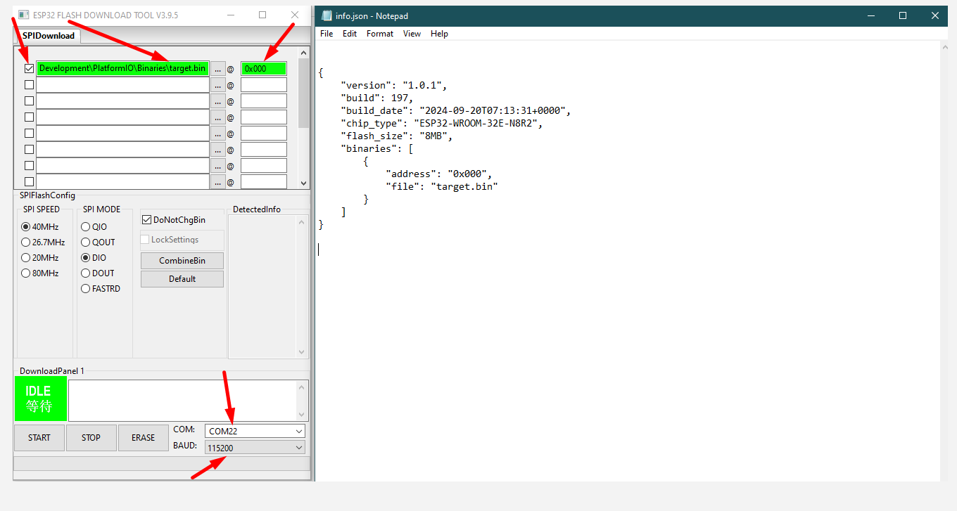
Guide for uploading Separate Binary files
As shown in the image below Click on the (…) (Three Dots) to locate individual provided separate binary files. Next make sure that there correct address are selected as shown in image below and click on the check boxes for them. Next select there correct Addresses as shown in image below select the correct COM port and Baud Rate and click Start button
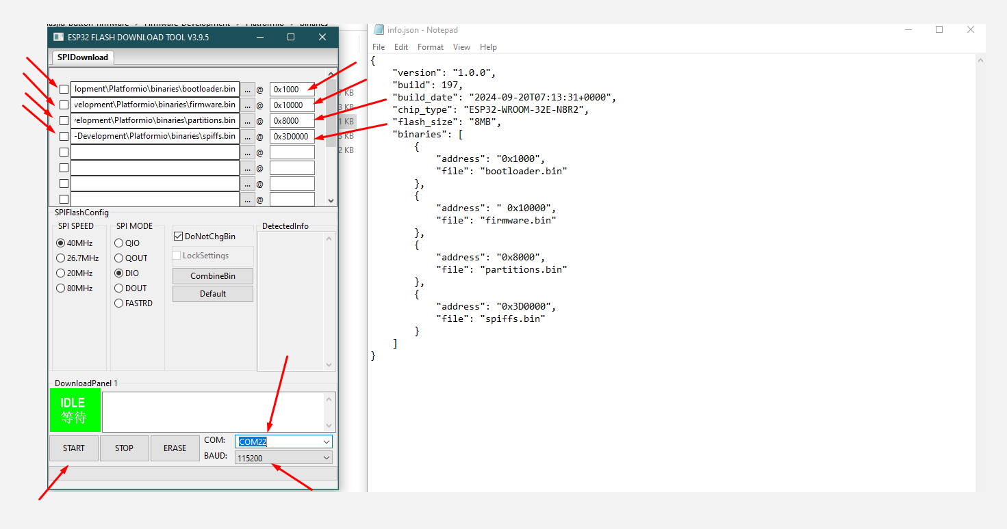
Program Output After Initial Code Upload:

Upon uploading the code for the first time, the following output is expected:
- After a few seconds, all three LEDs will begin to fade in and out in white for a short duration.
- Following the white fading effect, the LEDs will start blinking one after another in yellow. This indicates that Bluetooth has been turned ON.

